

Generation Cognizant (GenC)

Learner Handbook

Playwright – v1
Learning Journey Guide
Java Track – Full Internship

Why do we need this GenC learning Program?

Gen C learning program engages young talents with a comprehensive learning pathway, giving the millennials an opportunity to interact with Subject Matter Experts (SME), understand the corporate environment, and groom themselves.
Cognizant emphasizes on Learner Autonomy where students take charge of their own learning, with the available tools and resources. More focus is on “learning” than “teaching”. Get ready to embark your own learning adventure!


Program at a glance

Learning consisting of 2 Stages:
- Stage 1 – Front End , Scripting Language and Database
- Stage 2 – Playwright – Inclusive of the Project
Business Aligned Project
Interim Project Evaluation + Technical Evaluation
Final Project Evaluation + Final Technical Evaluation



Program Highlights
- The complete learning journey is formalized using adult learning principles, where problem solving and applying the skills gained are given more importance than conceptual learning.

- Learner Autonomy is encouraged via Flipped Classroom, where the learning platform offers world class learning resources, and students would not be constrained by tutelage of an instructor.

- Get mentored by SME, whose motivation and guidance will help you accelerate in the learning journey.

- This program is applicable to Interns as well as GEN Cs.

x

Know Your Service Line – QEA (Quality Engineer and Assurance)

Cognizant Quality Engineering & Assurance (QEA) focuses on ensuring the quality and reliability of enterprise processes, applications, and systems. QEA offers a comprehensive range of services including intelligent and automated quality assurance, modernization assurance, and experience assurance. These services are designed to accelerate business and technology changes, improve customer experiences, and ensure regulatory compliance. QEA also emphasizes the importance of automation and AI to enhance testing efficiency and deliver high-quality outcomes. By leveraging these advanced technologies, QEA helps businesses achieve digital success and maintain competitive advantage in the evolving digital landscape.
How QEA Transforms Quality Assurance at Cognizant?
Cognizant’s Quality Engineering & Assurance (QEA) significantly transforms quality assurance by accelerating digital transformation and ensuring robust, reliable applications and systems. This seamless transition minimizes disruptions and speeds up technology adoption.
By embedding quality at every development stage, QEA enhances customer satisfaction and loyalty through high-performance, user-friendly products. Automation and AI-driven quality assurance streamline processes, reducing manual efforts and speeding up release cycles, which boosts operational efficiency and cuts costs. Rigorous testing and validation ensure compliance with industry regulations, crucial for sectors like healthcare and finance.
QEA also supports innovation by providing a reliable foundation for launching new products and entering new markets. Additionally, automated testing frees employees to focus on strategic tasks, enhancing productivity and job satisfaction. These combined impacts help businesses achieve strategic goals, maintain a competitive edge, and deliver exceptional value to their customers.
Notable & Successful Stories on Quality Assurance by QEA Cognizant Team…
Cognizant’s Quality Engineering & Assurance (QEA) team partnered with a major health plan provider to overhaul their software quality assurance processes, addressing several critical challenges. The existing methods were outdated and inefficient, struggling to keep pace with the healthcare industry’s evolving needs.
Ensuring compliance with stringent healthcare regulations was a significant concern, and the manual, fragmented processes led to delays and increased operational costs. Additionally, there was a pressing need to improve software quality to enhance patient care and overall service delivery.
QEA implemented automated testing frameworks and AI-driven quality assurance tools, significantly reducing manual efforts and accelerating the testing process. Rigorous testing and validation processes were established to ensure compliance with healthcare regulations, including continuous monitoring and real-time compliance checks.
By streamlining quality assurance processes and integrating advanced technologies, QEA improved the overall efficiency of the software development lifecycle.
The focus on quality from the start ensured that end products were reliable and user-friendly, leading to better patient care and satisfaction. As a result, the health plan provider saw a significant improvement in software quality and compliance, which was crucial for meeting healthcare regulations.
The enhancements in software quality directly contributed to better patient care and service delivery, while the automation and streamlined processes led to faster release cycles and reduced operational costs.
The time-to-market for software updates was significantly reduced, allowing the client to respond more quickly to market demands. This project exemplifies how Cognizant’s QEA services can transform quality assurance processes, ensuring high-quality outcomes.
Health plan rebuilds software QA with Cognizant Case Study | Cognizant
Tips for Successfully Carrying Best Practices for Implementing and Maintaining Robust IT Infrastructure with QEA.
Understand the Basics: Start with a solid understanding of software development and testing fundamentals. Familiarize yourself with key concepts such as the software development lifecycle (SDLC), different types of testing (e.g., unit, integration, system, and acceptance testing), and the importance of quality assurance.
Learn Automation Tools: Gain proficiency in popular automation tools like Selenium, JUnit, and TestNG. Automation is crucial for efficient testing, and being skilled in these tools will enhance your ability to create reliable and repeatable tests.
Adopt the Page Object Model (POM): Use the Page Object Model design pattern to create maintainable and reusable code. This approach separates test logic from page elements, making your tests more organized and easier to manage.
Focus on Continuous Integration/Continuous Deployment (CI/CD):Understand and implement CI/CD practices. Tools like Jenkins help integrate testing into the development pipeline, ensuring that code changes are tested continuously and deployed seamlessly.
Embrace Agile and DevOps Practices: Agile and DevOps methodologies promote collaboration, speed, and quality. Learn how to work in these environments, focusing on continuous improvement and adaptability.
Prioritize Test Coverage: Develop comprehensive test plans that cover all aspects of the application, including functional, performance, security, and usability testing. Ensure that your tests are thorough and cover various scenarios.
Leverage AI and Machine Learning: Explore how AI and machine learning can enhance testing processes. These technologies can help predict potential issues, optimize test cases, and improve the overall effectiveness of quality assurance.
Implement Data-Driven Testing: Use data-driven testing to run the same test with different sets of data. This approach increases test coverage and ensures that your application works correctly with various inputs.
Maximize Browser Window: Ensure that your tests maximize the browser window to capture full-page screenshots and interact with all elements. This practice helps improve test accuracy and reliability.
Validate with Assertions: Use assertions to validate the outcomes of your tests. Assertions help ensure that the application behaves as expected and quickly identify any issues.
Continuous Learning and Improvement: Stay updated with the latest trends, tools, and best practices in quality assurance. Participate in training sessions, workshops, and online courses to continuously enhance your skills.
Collaborate and Communicate: Foster strong communication and collaboration with development, testing, and operations teams. Quality assurance is a shared responsibility, and effective teamwork is essential for success.
Learning Journey with Flipped Classroom

This program encourages you to be more autonomous learners during guided self-learning hours, completing the learning objectives on your own pace and style, and get ready for the hands-on practice time.
The complete learning path is set in the GEN C Learn Platform, which you can login with SSO.
Flipped Classroom

Recommended Program Sequence

The learning journey contains 2 stages, followed by a Business Aligned Project.
- Stage 1 – Front End , Scripting Language and Database
- Stage 2 – Playwright
- Business Aligned Project will provide you an experience of real time problem solving in Agile methodology.

Stage 1 – Front End , Scripting Language and Database

Stage 2 – Playwright

Key Learning Components of the Program

Cognizant has collaborated with Udemy to provide world class learning videos for the evolving future of work. These Udemy programs are woven into a learning path, empowering you to plan and learn at your style.
The program also connects you with Subject Matter Experts (SMEs) to get the professional guidance on your queries in the learning journey.
The program doesn’t ONLY concentrate on the technical skilling, but also on the shaping up of the Behavioral skills. Behavioral learning would be done in ILT mode, with few Self-paced learning modules too.
Evaluation Model
The program continuously evaluates if you can apply those self-learnt skills to solve a real-time business problem. Depicted below are the four key learning components, which are distributed across the learning journey for the purpose of continuous evaluation.
- Interim Evaluation (Project + Technical) through Video Interview
- Final Evaluation (Project + Technical) through Video Interview
The above evaluation components will attribute to the Performance Health Status (PHS) of a GenC. Additional Learning Components like Hands-On, Code Challenges and ICTs will help you to enhance your expertise level.
Interim & Final Evaluation Approach

Below is the Evaluation Structure for GenC Learning Journey
The interim evaluation will be held halfway through the learning journey, while the final evaluation will take place at the end of the learning journey.
During the interim evaluation, the GenC will be interviewed by a Technical Subject Matter Expert (SME) from the Business Unit (BU) to assess your knowledge through a technical discussion. Additionally, the Mini project completed by the GenC will also be evaluated by the BU SME. Please note that the Mini project is an individual activity and not a group activity.
During the final evaluation, the GenC will again be interviewed by a Technical SME from the BU to assess their knowledge through a technical discussion. In the same evaluation call, the Hackathon project completed by each group will be evaluated by the BU SME. Please note that the Hackathon project is a group activity and not an individual activity.
Preparatory Learning

For this automation track training, here are some preparatory learning materials that can be helpful for the interim and final technical evaluations. Preparatory learning material refers to resources, materials, and content that you can use to prepare. These materials are designed to provide you with the necessary knowledge, skills, and understanding to succeed in your learning objectives.

Remember, apart from these learning materials, actively participating in the training sessions, asking question and practicing hands-on exercises will greatly contribute to your overall learning and preparedness for the evaluations.
Program Completion Criteria

Stage 1 (Pre-requisites)
Gating Criteria: Qualifier Assessment

Stage 2 & Beyond (Advanced Skills)
Gating Criteria: Performance Health Status is Green

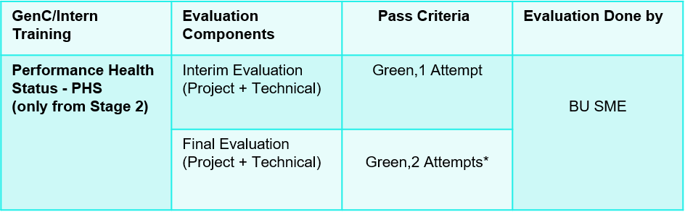

Outcome of Interim / Final evaluation will be RED, AMBER or GREEN status
Note: 100% Completion of Hands On in Stage 1 is mandatory for qualifier assessment and 100% Completion of Hands On in Stage 2 is mandatory for interim / final evaluation eligibility.
Key Check Point Intervals in the Learning Journey

Progressing to Stage 2 depends on clearing the qualifier assessment after stage1. Candidates who do not clear the Stage 1 Qualifier will be terminated from the Internship. However, based on the demand and later needs, they will be considered for the CSD mode of training.
For ICT Assessments – These ICT are set as practice assessments. Duration is 4 hours, and Attempts provided for user to practice the assessment is 3.
For CC Assessments – These CC are set as practice assessments. Duration is 2 hours, and Attempts provided for user to practice the assessment is 3.
Subsequent stages learning journey, your progress will be measured. On the below check point intervals, your overall Performance Health Score will be calculated as on date, and the RAG status will be arrived.
Table - Check Point Intervals
Check points | Interpreting Status
Interim Evaluation | - Green - On Track for Graduation  - Red /Amber - There will not be any re-attempts given
Final Evaluation | - Green - On Track for Graduation  - Red /Amber – Only 2 attempts are given  - (Attempt 2 is not applicable if the student is Red in Interim and Final Evaluation- Attempt 1)  Note: If student fails after the applicable re-attempts, they will be considered as “Not-Graduated”.



Icebreaker
Icebreaker session will be conducted for a duration of initial 5 days. During the session, various topics related to Corporate Induction, Talent Management, Cognizant Agenda on Core Values, Leader Talks, Alumni, BU Mentor connects will be covered. Followed by icebreaker, technical training will kick start.

Following sessions will be covered during the 5 days of icebreaker

- Corporate Induction
- Talent Manager Connect
- Cognizant Agenda Sessions on Core Values
- Leader Talks (Academy) and many more…

A recommended day-wise schedule is provided below for the learning, with the learning content for the day, the practice hands-on and extended hands-on to be done for the day or
any other activities are listed. Few days might be interleaved to accommodate the extension due to Behavioral Training.
Mock Interview Session: This session is conducted to test candidate understanding and enhance candidates’ best preparation for Interim & Final Evaluations.
GenAI-Program Overview

Introduction
AI Accelerate is a comprehensive program designed to empower learners with the knowledge and skills needed to harness the transformative potential of Artificial Intelligence (AI). This handbook serves as a guide, providing essential information and resources to help learners navigate through the program successfully. From understanding the fundamentals of AI to apply the advanced concepts in real-world scenarios. AI Accelerate is your gateway to unlock the power of AI and shaping the future of technology.
Program overview.
AI Accelerate offers a learning opportunity, allowing GenCs to engage learning through the self-paced learning, Expert connect, and Knowledge assessment to measure the skills.
Focus areas
- Learning: GenCs will have access to curated content and resources that cover a wide range of topics related to AI, including best practices, and case studies. This learning aspect aims to deepen GenCs understanding of AI and its applications in various industries.
- Expert connect: GenCs will have the opportunity to connect with expert in the field of AI. This expert will provide guidance, support, and insights to help GenCs navigate their learning journey and gain valuable insights into the industry.
- Practice sessions: GenCs can practice the use cases provided sessions that are designed to reinforce their learning and help them apply their knowledge in real-world scenarios. These sessions will provide GenCs with hands-on experience and practical skills that are essential for success in the field of AI.
Performance outcomes
Upon completing the self-paced learning component of AI Accelerate GenCs are expected to achieve the following performance outcomes:

- GenCs will demonstrate a thorough understanding of the fundamentals of AI, including key concepts, terminology, and principles.
- GenCs will be able to apply AI concepts and techniques to solve real-world problems, demonstrating their ability to analyze, design, and implement AI solutions.
- GenCs will develop and apply critical thinking and problem-solving skills in the context of AI, enabling them to identify, analyze, and address complex challenges.
- GenCs will collaborate effectively with peers, mentors, and industry experts to achieve common goals and contribute to the advancement of AI knowledge and practice.

Program workflow

Schedule – Stage 1: Day 1 to 20

Udemy learnings are recommended in the Platform to understand the fundamental concepts. Apply the concepts learned and solve the Hands-on and Practice Case studies as recommended below.
Continuous Learning: Technical Hands-on through Tekstac
Post Completion of the ILT session, Trainee must Practice the Handson provided in the Tekstac Platform . In build code editor is available in this platform and Handson are automatically evaluated when the code is compiled in the editor.
Day 1 to 13

Front End - HTML, CSS, XML , JSON

Day 1 to 4 will be focusing on Front End - HTML, CSS, XML and JSON

Continuous Learning: ILT Enablement

Learn and Practice
 | Web Development Concepts for Everyone  Refer all section in this Udemy course and complete the corresponding learnings.

 | The Web Developer Bootcamp 2024  Refer all section in this Udemy course and complete the corresponding learnings.

Continuous Learning: Technical Hands-on through Tekstac
Mandatory Hands-on – HTML
- Newberry Library
- Jasper Sports Academy

Mandatory Hands-on – CSS
- Whatsapp Chat
- Calculator
- 4*4 Sudoku

 | Learn API Technical Writing: JSON and XML for Writers  Refer all section in this Udemy course and complete the corresponding learnings.

Mandatory Hands-on – XML JSON
- Well Formed XML - Movie Detail
- Well Formed XML - CookBook - Recipe Detail
- Well Formed XML - Movies Info
- Well Formed XML - Multiple Job Details
- Account Transactions - Object with Array - JSON
- Weather Forecasting - JSON

Day 5 to 9 will be focusing on Scripting Language : JavaScript, nodejs

Continuous Learning: ILT Enablement

Learn and Practice
 | Playwright JS/TS Automation Testing from Scratch & Framework  Refer section 23 in this Udemy course and complete the corresponding learnings.

Learn and Practice
 | JavaScript & Node.js course for Testers, QA and SDETs - 2025  Refer section 23 in this Udemy course and complete the corresponding learnings.

Mandatory Hands-on – JavaScript
- Schedule Upcoming Match
- Event Reservation Portal
- SignUp Form validation
- Fitness Centre
- Product Code Validation
- Display Student Details
- Counting Game

Mandatory Hands-on – Nodejs
Nodejs: Crud
- Add an Employee into Collection
- Add Training Information
- Delete collection
- Count Based On Job
Nodejs: Aggregation
- Embedded Document
- Employees Details Based On Hired Year
- User Defined Index
Nodejs: Indexing
- Create a Unique Index
- Create a Composite Index
- Index Info

NOTE : On DAY 5 - Once completing Udemy course, Learnings, all Handson & Practice assessments related to Frontend skill appear for the HTML5 and CSS3 -Code Challenge Assessment. This will help you to assess and apply the concepts of the skill learnt in the platform.

Assess-Type-1: Code Challenge - HTML5 and CSS3

Assessment Duration: 2 hrs.
Assessment Attempts: 3
No.of Questions appear in each attempt: 1

NOTE : On DAY 9 - Once completing Udemy course, Learnings, all Handson & Practice assessments related to Frontend skill appear for the JavaScript -Code Challenge Assessment. This will help you to assess and apply the concepts of the skill learnt in the platform.

Assess-Type-1: Code Challenge - JavaScript

Assessment Duration: 2 hrs.
Assessment Attempts: 3
No.of Questions appear in each attempt: 1

Day 10 to 13

Scripting Language : TypeScript

Day 10 to 13 will be focusing on TypeScript.

Continuous Learning: ILT Enablement

Learn and Practice
 | TYPESCRIPT FOR BEGINNERS  Refer all section in this Udemy course and complete the corresponding learnings.

Continuous Learning: Technical Hands-on through Tekstac
Mandatory Hands-on – Typescript
- Weightlifting Competition
- Anniversary Celebration
- Bookstore Inventory Management
- Student Grade Management System
- TechWorks - Enum
- T20 Score Analysis
- Number-String Game - Rest
- Type-based Process
- Lucky Wish

Day 14 to 18

SQL Advanced

Day 14 to 18 will be focusing on SQL

Continuous Learning: ILT Enablement

Learn and Practice
 | EssentialSQL: Data Modeling & Relational Data Architecture  Refer all section in this Udemy course and complete the corresponding learnings.

 | The Ultimate MySQL Bootcamp: Go from SQL Beginner to Expert  Refer all section in this Udemy course and complete the corresponding learnings.

Continuous Learning: Technical Hands-on through Tekstac
Mandatory Hands-on – DDL
- Create Borrowing Table
- Alter Table User
- Alter Table Book
- Remove Table

Mandatory Hands-on – DML
- Insert User Table
- Update Record
- Delete Record

Mandatory Hands-on – SELECT STATEMENT
- Diverse Selection
- Email Providers
- Book Event
- Upcoming Fair
- Routine Checks
- Security Measure
- May Birthday
- Age Demographics
- Author Detail
- Price Analysis
- Updated Email

Mandatory Hands-on – AGGREGATE FUNCTIONS
- Lended Books
- The Chronicles of Authors and Their Tales

Mandatory Hands-on – JOINS AND SUBQUERIES
- Exploring Users' Literary Journeys
- Date Format
- Active Borrowings with User and Book Details
- Maximum Fine Per User
- Same Authors
- Top Users
- User Borrowing Summary
- User Count by Title and Author

Note: On Day 15 - Once completing Udemy course, Learnings, all Handson & Practice assessments related to SQL Advanced skill appear for the SQL -Code Challenge Assessment. This will help you to assess and apply the concepts of the skill learnt in the platform.
Code Challenge
Assess-Type-1: Code Challenge - RDBMS Select Statements

Assessment Duration: 2 hrs.
Assessment Attempts: 3
No.of Questions appear in each attempt : 1

Note: On Day 15 - Once completing Udemy course, Learnings, all Handson & Practice assessments related to Web UI-SQL skill appear for the SQL -Code Challenge Assessment. This will help you to assess and apply the concepts of the skill learnt in the platform.
Code Challenge
Assess-Type-1: Code Challenge - DDL, DML & Select (QEA)

Assessment Duration: 2 hrs.
Assessment Attempts: 3
No.of Questions appear in each attempt : 1

Note: On Day 16 - Once completing Udemy course, Learnings, all Handson & Practice assessments related to Web UI-SQL skill appear for the SQL -Code Challenge Assessment. This will help you to assess and apply the concepts of the skill learnt in the platform.
Code Challenge
Assess-Type-1: Code Challenge - Functions & SubQueries

Assessment Duration: 2 hrs.
Assessment Attempts: 3
No.of Questions appear in each attempt : 1

Note : On Day 17 - Once completing Udemy course, Learnings, all Handson & Practice assessments related to (Javascript, SQL advanced , XML , JSON ; HTML CSS ) skill appear for the MOCKQualifier Assessment. This will help you to assess and apply the concepts of the skill learnt in the platform. Question Pattern – (SBA) Skill Based Assessment Coding based Javascript, SQL advanced , XML , JSON Questions and KBA Skill Based Assessment Coding MCQ based Question from HTML CSS.

MOCK Qualifier Assessment

Assessment Duration: 3 hrs.
No.of Questions:(Javascript – 1 Coding SBA Question
SQL advanced – 1 Coding SBA Question
XML , JSON – 10 MCQ KBA Question
HTML CSS – 10 MCQ KBA Question

Day 19

Once completing Udemy course, Learnings, all Handson & Practice assessments related to (Javascript, SQL advanced , XML , JSON ; HTML CSS ) skill appear for the Qualifier Assessment. This will help you to assess and apply the concepts of the skill learnt in the platform. Question Pattern – (SBA) Skill Based Assessment Coding based Javascript, SQL advanced , XML , JSON Questions and KBA Skill Based Assessment Coding MCQ based Question from HTML CSS.

Qualifier Assessment
Assessment Duration: 3 hrs.
No.of Questions:(Javascript – 1 Coding SBA Question
SQL advanced – 1 Coding SBA Question
XML , JSON – 10 MCQ KBA Question
HTML CSS – 10 MCQ KBA Question
Schedule – Stage 2: Day 20 to 55

Day 20 - 24

Functional Testing Agile Scrum

Continuous Learning: Technical Enablement

Learn the basics of Functional Testing Agile Scrum

Functional Testing

Continuous Learning: Technical Enablement

Learn the basics of Software Testing Life Cycle
 | Learn Manual Software Testing + Agile with Jira Tool  Refer all section in this Udemy course and complete the corresponding learnings.
Continuous Learning: Technical Hands-on
Mandatory Hands-on
- Hotel Booking
- Students Enquiry Form

Continuous Learning: Reference Learning


Agile Fundamentals: Including Scrum & Kanban

Note : On Day 24 - Once completing Udemy course, Learnings, all Handson & Practice assessments related to Functional Testing skill appear for the Functional Testing -ICT Assessment. This will help you to assess and apply the concepts of the skill learnt in the platform. Attempts allowed to practice the assessment is 3.

Assessment Duration: 4 hrs
Assessment Attempts: 3
No.of Questions appear in each attempt : 1

Functional Testing -Assess Type 2 Skill Based Assessment.
- Read the requirements carefully of the Assessment Question.
- Write the Defect Description for the Test Case in Excel Sheet
- Submit the Test deliverables

Schedule – Stage 2: Day 25 to 55

Day 27 to 39 will be focusing on Playwright Concepts.
Udemy learnings are recommended in the Platform to understand the fundamental concepts.
Apply the concepts learned and solve the Hands-on and Practice Case studies as recommended below.
Business Aligned Project (Mini Project & Hackathon)

As the selenium learning starts, the project details (Mini project and the Hackathon) will be given for the learners so that they can parallel keep doing the project activities along with the rest of the learnings.

• Mini project in selenium is a great way to deepen your understanding, showcase your
skills, and prepare for real-world automation tasks.
• It allows to apply theoretical knowledge of Selenium and web automation in a practical,
real-world scenario. Working on a project helps you gain hands-on experience with
Selenium WebDriver, locators, and other essential components.
• Building a mini project helps you understand the design and implementation of
automation frameworks, such as Page Object Model (POM) and Data-Driven Testing.
• You can integrate Selenium with other tools like TestNG for test management and
reporting.

Mini Project & Hackathon – Objective

• CI/CD Integration: Integrating your Selenium tests with CI/CD tools like Jenkins helps
automate the testing process as part of the build pipeline.
• Automated Testing: Ensures that your application is tested automatically with every
code change, improving software quality.
• Reporting and Logging: Generate detailed test reports that provide insights into test
execution, pass/fail status, and error details.
• Logging: Implement logging to capture detailed information about test execution, which
is useful for debugging and analysis.
• Reusable Code: Writing reusable and maintainable code is a key aspect of any project,
and a mini project helps you practice this.
• Collaboration: It encourages collaboration and teamwork, as you can divide tasks
among team members and integrate their work using Selenium.
• Exception Handling: You’ll learn to handle exceptions and errors that occur during test
execution, making your scripts more robust.
• Debugging Skills: Debugging skills are enhanced as you troubleshoot issues in your
automation scripts etc.

The given Mini Project and the Hackathon are expected to be completed on or before the end week of the program.

Project Evaluation will be based on:
- Source Code
- Functionality Completion, Usage of Features, Code Quality
- Demo of Output
Note:
Mini Project is an individual team member activity. Project Requirement is available in the platform. Candidates must complete the requirement and submit the solution for evaluations by BU SME.
Hackathon is an individual activity. Project requirement is available in the platform. Candidates must complete the requirement and submit the solution for evaluations by BU SME.

Day 27 - 39

Playwright

Continuous Learning: ILT Technical Enablement

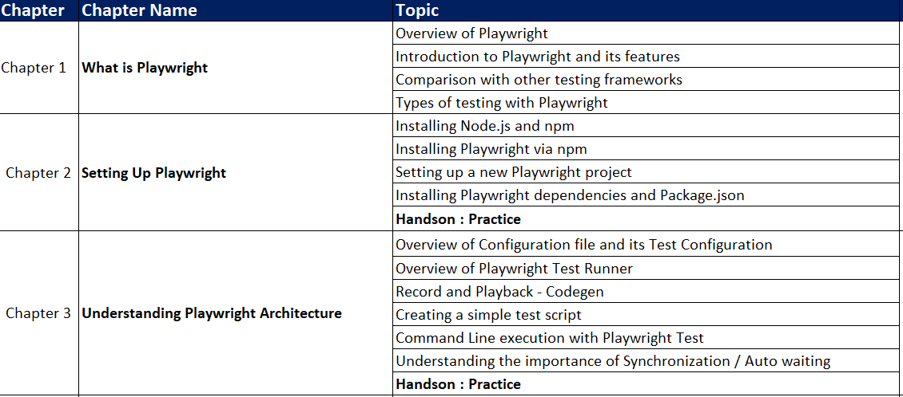
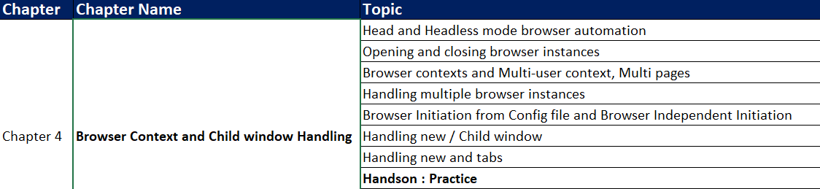
Continuous Learning: Technical Enablement through Self-learning
Learn the basics of Playwright
 | Playwright JS/TS Automation Testing from Scratch & Framework  Refer all section in this Udemy course and complete the corresponding Subtopics.
Learn the basics of WebDriver Basics
 | Master Playwright V1.49 + Docker, Cucumber, Jenkins -JAN'25  Refer section 12 - 15 in this Udemy course and complete the corresponding Subtopics  Section 12: Framework Designing – Part 1  Section 12: Framework Designing – Part 2  Section 12: Framework Designing – Part 3  Section 12: Framework Designing – Part 4

Continuous Learning: Technical Enablement through Self-learning
Mandatory Hands-on
- Chapter 2_Handson
- Chapter 3_Handson
- Chapter 4_Handson

Project – Mini Project Case Study

Overall Duration: Should start your mini project parallel with the Stage 2 Playwright learnings.

The outcomes of doing Mini Project are:
- Enables learners to know on the environment setup
- Any web application is taken, and learner try to automate given scenario using Playwright APIs.
- Exhibits learner skills on automation of real time applications for smaller requirement.

GenAI (Day 29)

Continuous Learning: Technical Enablement

AI Accelerate

- By this course you will complete GenAI self-pace learning , AI expert connect session and AI Knowledge check assessment.

Program completion criteria
Everyone must register for the following e-learning course on C-Learn and complete a KBA assessment on Moodle to successfully finish this program.
Online learning: C-Learn

  Activity Code: ELRNG01863 | Fundamentals of Generative AI [101-Basics]  This AI course is designed to equip learners with:  The foundational knowledge and skills required to harness the power of Generative AI.  The ability to identify opportunities for innovation and implementation of AI within their organizations.  The skills to drive organizations toward a future of enhanced creativity and competitive advantage using AI techniques.
Project – Mini Project Case Study
- Integrate the mini project and implement progress on daily basis.

Playwright

Continuous Learning: ILT Technical Enablement

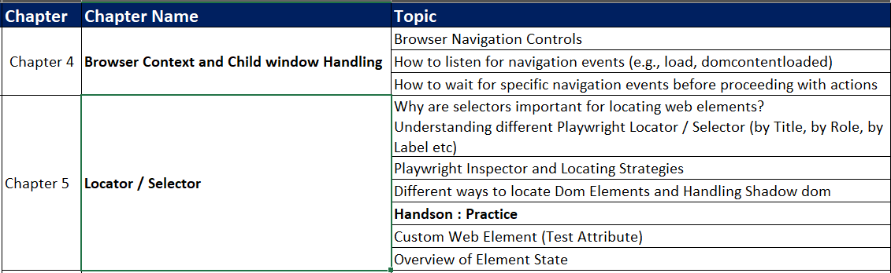

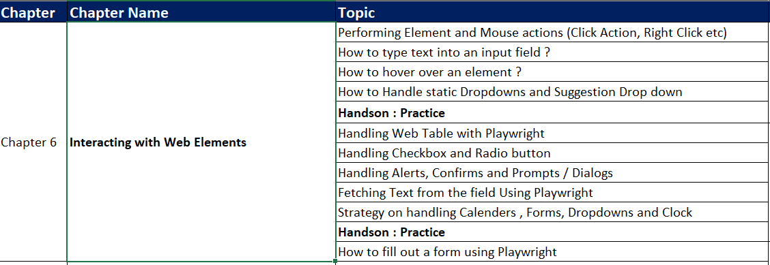

Continuous Learning: Technical Enablement through Self-learning
Mandatory Hands-on
- Chapter 4_Handson
- Chapter 5_Handson
- Chapter 6_Handson
Project – Mini Project Case Study
- Integrate the mini project and implement progress on daily basis.

GenAI (Day 31)

Knowledge check - Moodle

  Activity Code: ATHDW335105 | GENERATIVE AI QUICK ASSESSMENT FOR ELEARNING QUIZ [101-BASICS]  - This assessment is to assess the knowledge of associates on Generative AI tools and concepts at a Beginner proficiency.

Playwright

Continuous Learning: ILT Technical Enablement

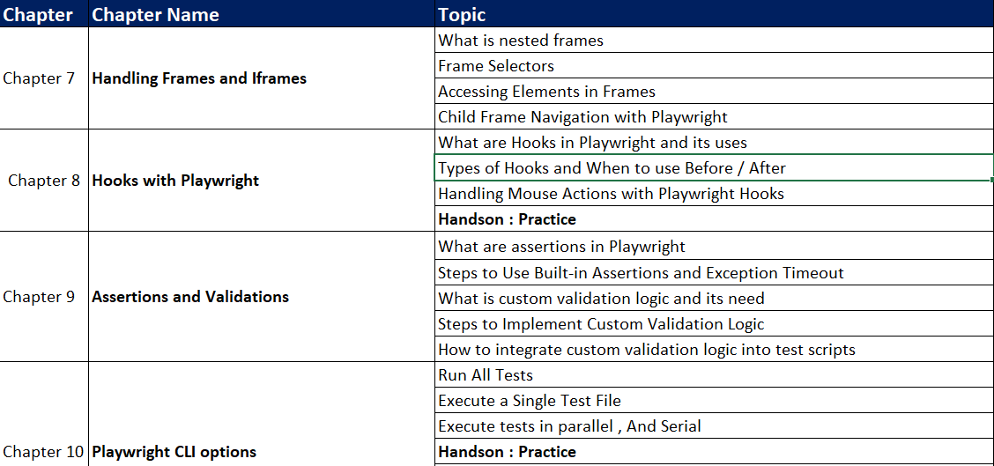

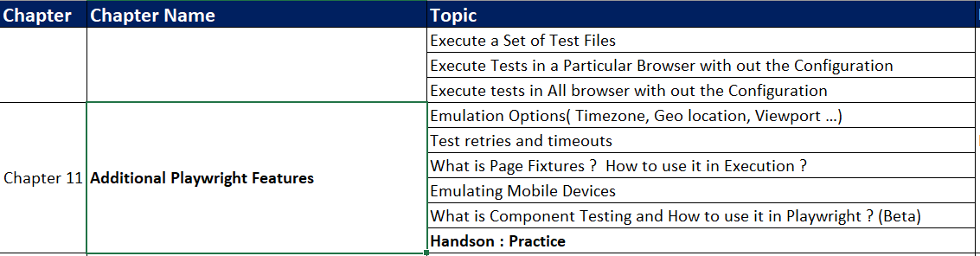
Mandatory Hands-on
- Chapter 7_Handson
- Chapter 8_Handson
- Chapter 9_Handson
- Chapter 10_Handson
- Chapter 11_Handson

Project – Mini Project Case Study
- Integrate the mini project and implement progress on daily basis.

Playwright

Continuous Learning: ILT Technical Enablement

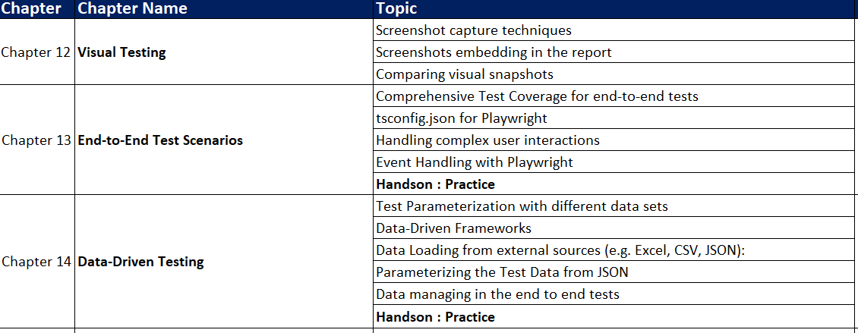

Continuous Learning: Technical Enablement through Self-learning

Mandatory Hands-on

- Chapter 12_Handson
- Chapter 13_Handson
- Chapter 14_Handson

GenAI

Additional Learning: Technical Enablement

Try to complete the following additional Udemy courses (Optional) to learn more about GenAI and ChatGPT.

Courses | Duration (in hrs.) | What you’ll learn
Generative AI for Beginners | 3.5 | - Detailed understanding of Generative AI  - Key concepts - LLM, Embeddings, Prompt Engineering, Fine Tuning  - Industry use cases and ideas that can be implemented  - Hands-on experience, creating a chatbot  - Future trends and how to stay relevant in post-GenAI world.  - Roadmap for continuous learning
Intro to ChatGPT and Generative AI | 1.5 | - How to prompt ChatGPT effectively  - How to skyrocket productivity using AI  - Understand Generative AI and the underlying technology  - Grasp the importance of AI ethics

Project – Mini Project Case Study
- Integrate the mini project and implement progress on daily basis.

Playwright

Continuous Learning: Technical Enablement through Self-learning

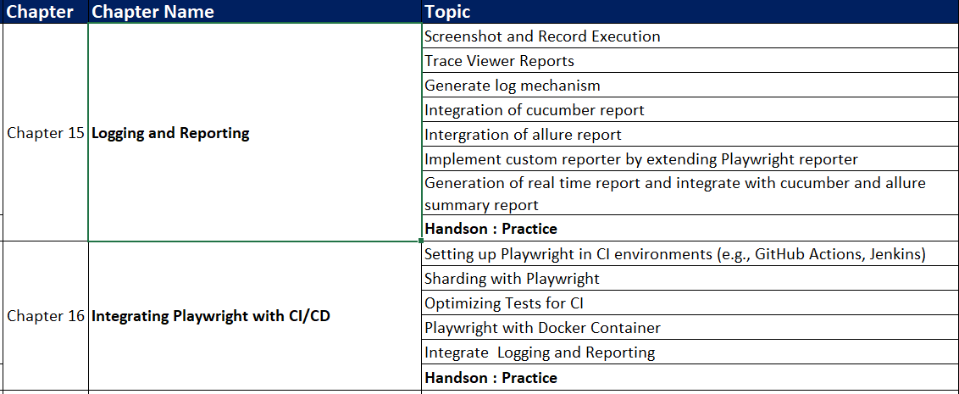

Mandatory Hands-on
- Chapter 15_Handson
- Chapter 16_Handson

Project – Mini Project Case Study
- Integrate the mini project and implement progress on daily basis.
Playwright

Continuous Learning: ILT Technical Enablement

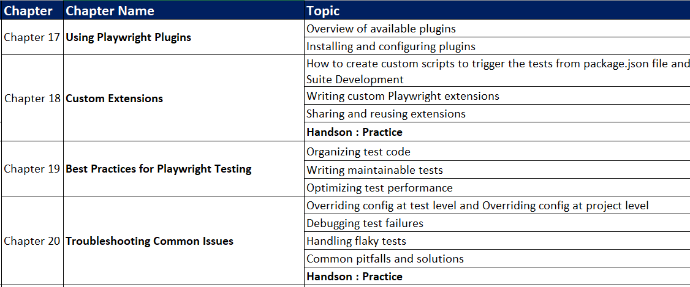

Continuous Learning: Technical Enablement through Self-learning
- Chapter 17_Handson
- Chapter 18_Handson
- Chapter 19_Handson
- Chapter 20_Handson

MOCK Evaluation through AI BOT (Day 39)
This is an auto-scheduled, AI-driven mock interview, intended to be taken before the interim evaluation. You will receive an auto-scheduled email notification three hours prior to the evaluation.
Details:
- Platform: Mail-driven platform
- Scope: AI will ask questions based on everything you have learned up to date
- Duration: 1.5 hours
- Questions: 15 skill-based Coding questions

Once you complete the evaluation, AI will provide feedback on your performance. This helps you to appear for Interim Evaluation.

Day 40 & 41

Evaluation:
Interim Project Evaluation + Technical Evaluation

Day 42 - 46

Handling APIs with Playwright
You will be focusing on Handling APIs with Playwright.
 | Master Playwright V1.49 + Docker, Cucumber, Jenkins -JAN'25  Refer section 16 – 21 in this Udemy course and complete the corresponding learnings.  Section 16: API Testing  Section 17: Cucumber  Section 18: Docker Integration with Playwright  Section 19: Jenkins (CICD) Integration  Section 20: Additional Content  Section 21: Project Download

 | Automated Web Testing with JavaScript and Playwright  Refer all section 3 in this Udemy course and complete the corresponding Subtopics.  Section 3: Advanced Techniques

Day 47 - 48

CI Integration

You will be focusing on CI Integration.
 | Automated Web Testing with JavaScript and Playwright  Refer all section 3 in this Udemy course and complete the corresponding Subtopics.  Section 4: CI Systems and Version Control with GitHub

Day 49 - 52

Project - Hackathon
- Integrate the project and work on daily basis.

Deliver your project and get the review comments from SME.

The deliverables of the Hackathon will be evaluated by the BU SME.
Project Evaluation will be based on:

- Source Code
- Functionality Completion, Usage of Features, Code Quality
- Demo of Output

MOCK Evaluation through AI BOT (Day 52)
This is an auto-scheduled, AI-driven mock interview, intended to be taken before the interim evaluation. You will receive an auto-scheduled email notification three hours prior to the evaluation.
Details:
- Platform: Mail-driven platform
- Scope: AI will ask questions based on everything you have learned up to date
- Duration: 1.5 hours
- Questions: 15 skill-based Coding questions

Once you complete the evaluation, AI will provide feedback on your performance. This helps you to appear for Interim Evaluation.

Day 53 - 55

Evaluation:
Final Project Evaluation + Technical Evaluation
What is Final Evaluation?  The Final Evaluation will be conducted to certify whether a GenC is eligible to enter into the BU or not. The skill of a GenC will be gauged on the application development and overall technical knowhow towards the end of GenC Training.  Tech SME from BU will be conducting the final tech evaluation. As a fallback, the project mentor can also steer this activity.  The final evaluation will be conducted as two phases. They are the following  - Final Technical Evaluation  - Final Project Evaluation  The mode of these evaluations will be any one of the following:  - F2F(face to face)  - Video Based  1. Final Technical Evaluation (FTE)  The BU Mentor will interview the GenC on various skills achieved throughout the training program and put a score which will be considered for the final PHS of the GenC. | 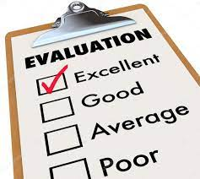
2. Final Project Evaluation (FPE)

In this evaluation, the BU Mentor will be verifying the skills of a GenC on a project perspective. End of this evaluation, the BU Mentor will score the GenC’s work based on various evaluation criterions.

How to learn each day?

Each day has a set of learning objectives. These learning objectives can be met by going through the Udemy courses and by completing the hands-on exercises mentioned in the daily plan.

The below strategies will help you decide the learning approach.

Learning Strategy & Approach
Find below few imaginary profiles. For each of these profiles we have defined a recommended learning approach. This is not an exhaustive list. The approaches below might help invent a new way of learning.

Profile #1
 | Harry Reacher  Engineering Discipline: Electronics  Skills: Python, Ruby on Rails, nginx  Project: Mining Crime Data to get Route Cause Insights  Learning Approach to Programming Languages: I do not want to waste my time learning. I am more practice oriented. I want to work on the problem immediately
What will work for me?
- Directly complete hands on exercises
- Refer Internet or Udemy Courses
- If hands on are implemented early, clarify your friends questions and troubleshoot their issues

Profile #2
 | Olivia Richards  Engineering Discipline: Computer Science  Skills: Java, C, C++  Project: Library Management System  Learning Approach to Programming Languages: I have interest, but I don’t know where to start.
What will work for me?
- Go through the recommended Udemy Course
- Try completing the hands on exercises
- Get your clarifications solved with help from Tech SME
- Get help from other learners in your batch whom had already completed

Profile #3
 | Greg Anderson  Engineering Discipline: Civil  Skills: C  Project: Fiber reinforced concrete  Learning Approach to Programming Languages: I am scared of programming languages. I haven’t got my hands dirty with coding
What will work for me?
- Go through the recommended Udemy Course
- Implement the coding along with the author of the Udemy Course
- Try completing the hands on exercises
- Clarify queries with SME
- Troubleshoot programming issues with help from SME or learner from your classroom whom had already completed

FAQ

- Who can participate in this program?
Students who have enrolled for Full Internship Program (or) the Cognizant on-boarded GEN Cs can participate in this program.

- Is there any pre-learning I should do?
No. This program is open to all students from any academic discipline.

- How will I know my RAG status?

It will be shown to you in the GEN C learn Platform, in your Home Page.

- Whom do I reach out in case of any queries?
Coach is your point of contact.

- What is the significance of Hands-on in the overall learning journey?
Hands-on focuses on specific topics in a Skill, which you can try and execute in the
Platform. Group of such Hands-on exercises will be packaged together as a Code
Challenge. This Code Challenge will allow you to benchmark your skills in the learning
journey. Hands On/ Code Challenges/ ICT are learning components which will help you in
understanding the skills better.

- What is Code Challenge?
A problem statement will be provided to you and you need to solve it using a single skill.

- What is Integrated Capability Test (ICT)?
A case study problem statement will be provided to you, that you may need solve using the combination of Skills learnt in the given stage.

- How many attempts are provided for the Coding challenge and ICTs? Is it open all the time for practice?
The Coding challenges and ICTs are open and there are 3 attempts to take them up.

- What is the entry criteria for qualifier?
A minimum of 70% hands-on completion and attempt in the CC & ICT is the eligibility criteria for qualifier.

- What skills are covered in the qualifier?
The skills of Stage 1 are covered in the qualifier. Only ONE attempt is provided to clear with a minimum score of 70%

- What if I fail in the Interim evaluation?
Your coach will notify your performance in the Interim evaluation. However you can continue with the learning.
- How many chances will I get in the Final evaluation?
You’ll get 2 chances in the Final evaluation which covers ALL the skills in the learning journey.

- Whom do I reach out in case of any queries?
Coach is your point of contact.

